**Issue Trees: The Ultimate Guide with Detailed Examples**

Issue trees are powerful tools that consultants at McKinsey and other consulting firms use to solve business problems. By the end of this article, you will learn how to create issue trees and see examples of issue trees to common types of case interviews.

**Issue Tree Definition and Importance**

Issue trees break down complex problems into distinct, smaller components. Issue trees typically take on the following structure:

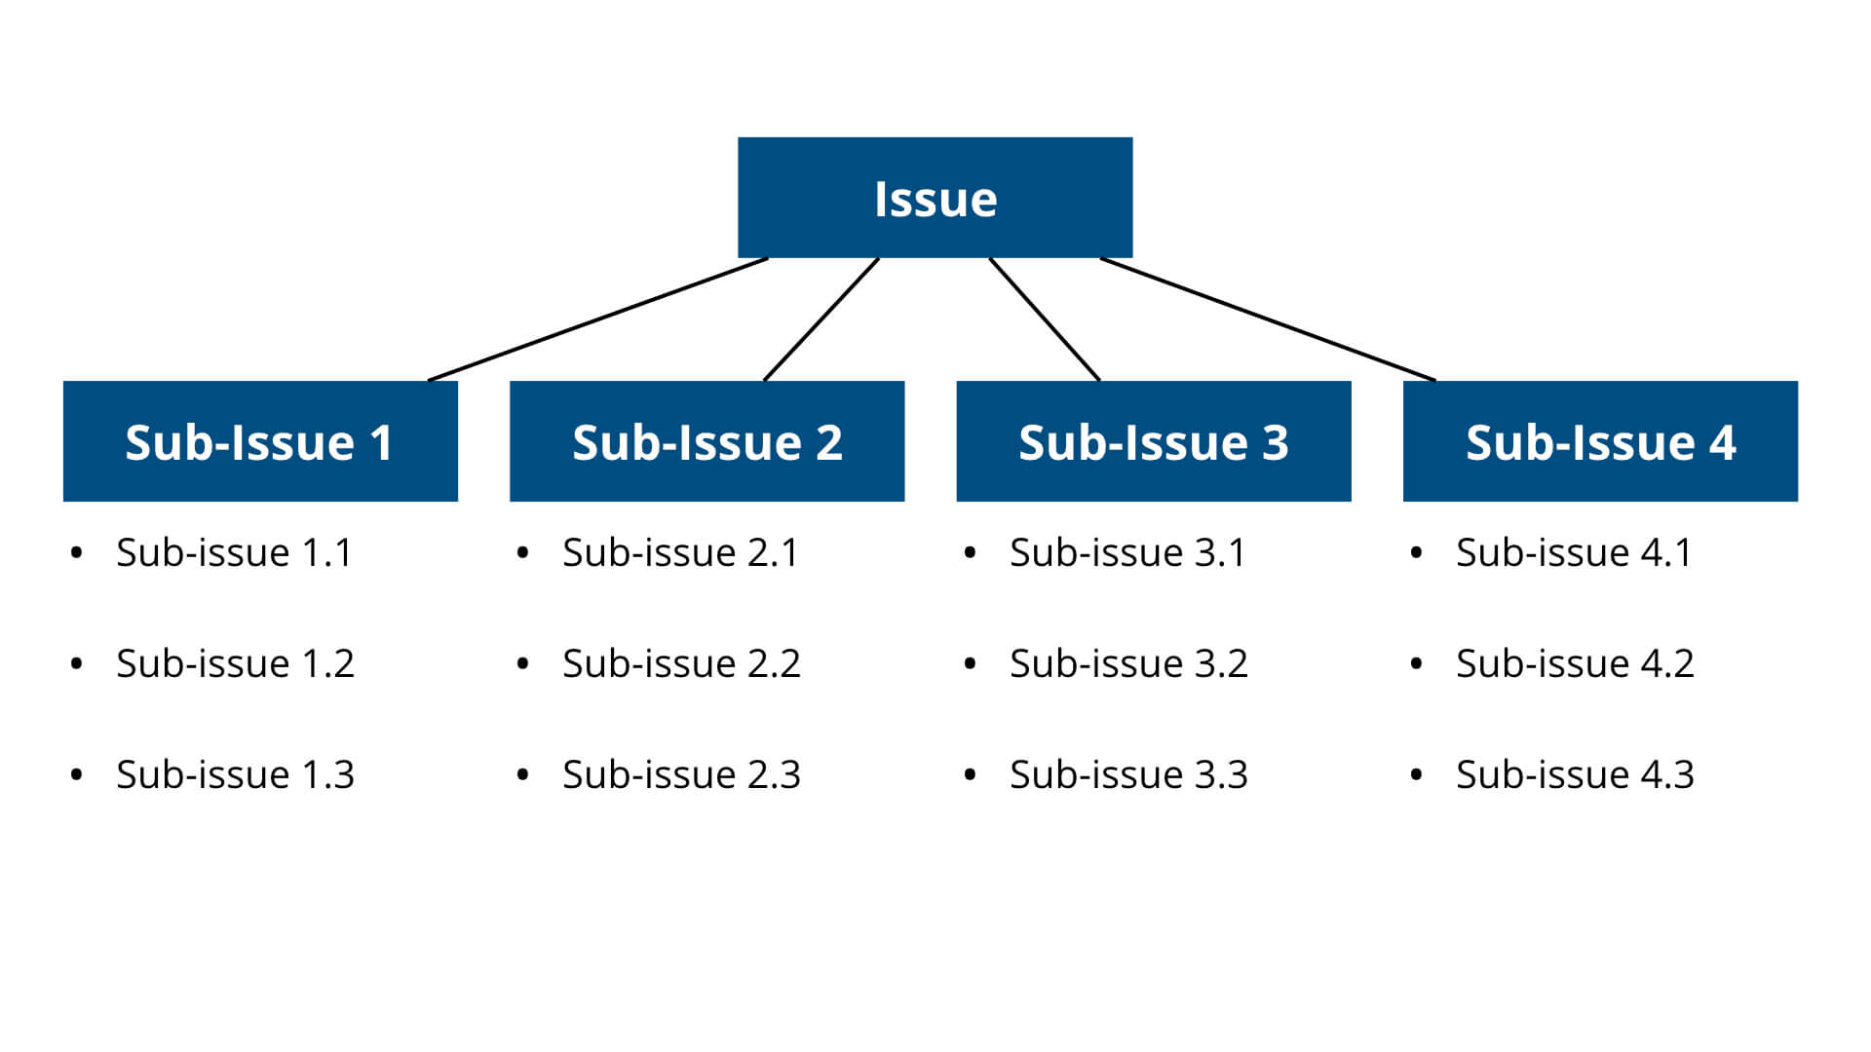

Issue trees get their name because the primary issue that you are solving for can be broken down into smaller issues or branches. These issues can then be further broken down into even smaller issues or branches.

This can be continued until you are left with a long list of small issues that are much simpler and more manageable. No matter how complicated or difficult a problem is, an issue true can provide a way to structure the problem to make it easier to solve.

As an example, let’s say that we are trying to help a lemonade stand increase their profits. The overall problem is determining how to increase profits.

Since profits is equal to revenue minus costs, we can break this problem down into two smaller problems:

* How can we increase revenues?

* How can we decrease costs?

Since revenue is equal to quantity times price, we can further break this revenue problem down into two even smaller problems:

* How can we increase quantity sold?

* How can we increase price?

Looking at the problem of how to increase quantity sold, we can further break that problem down:

* How can we increase quantity of lemonade sold?

* How can we increase quantity of other goods sold?

We can repeat the same procedure for the costs problem since we know that costs equal variable costs plus fixed costs.

* How can we decrease variable costs?

* How can we decrease fixed costs?

Looking at the problem of how to decrease variable costs, we can further break that down by the different variable cost components of lemonade:

* How can we decrease costs of lemons?

* How can we decrease costs of water?

* How can we decrease costs of ice?

* How can we decrease costs of sugar?

* How can we decrease costs of cups?

The overall issue tree for this example would look like the following:

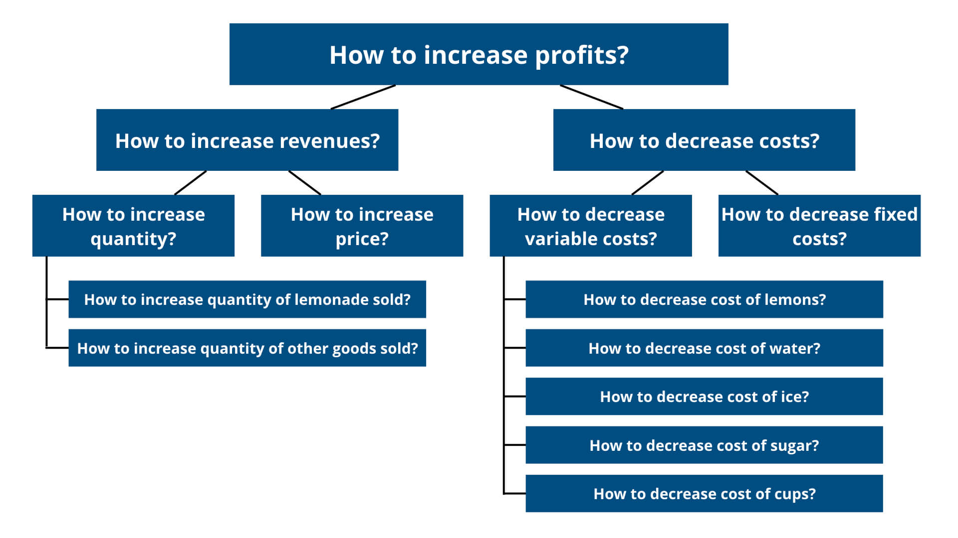

This issue tree is a special kind of issue tree known as a profit tree.

So, what benefits do issue trees provide?

There are four primary benefits.

**1. Issue trees make problems easier to solve**: Issue trees take a broad business problem and break it down into smaller and more specific questions, which are easier to handle and solve.

**2. Issue trees provide a roadmap for how to solve the problem**: Issue trees lay out exactly all of the different areas or issues that you need to focus on in order to solve the overall problem. This gives you a clear idea of where to focus your attention and work on.

**3. Issue trees enable you to divide up work**: Issue trees provide you with a list of smaller, distinct problems or areas to explore. This distinction makes it easy for you to divide up work with your team.

**4. Issue trees enable you to prioritize**: You may not have the time to tackle or solve the entire list of smaller, specific issues from your issue tree. Therefore, this forces you to prioritize which issues are the most important to focus on. You should be spending most of your time on the most impactful areas.

**What Qualities Make a Great Issue Tree?**

Issue trees are powerful tools to solve complex business problems, but they are much less effective if they don’t follow two key principles.

**Issue tree principle #1: MECE**

**MECE** stands for mutually exclusive and collectively exhaustive. When breaking down the overall problem in your issue tree, the final list of smaller problems needs to be mutually exclusive and collectively exhaustive.

**Mutually exclusive** means that none of the smaller problems in your issue tree overlap with each other. This ensures that you are working efficiently since there will be no duplicated or repeated work.

For example, let’s say that two of the issues in your issue tree are:

* Determine how to increase cups of lemonade sold

* Determine how to partner with local organizations to sell lemonade

This is not mutually exclusive because determining how to partner with local organizations would include determining how to increase cups of lemonade sold.

In determining how to increase cups of lemonade sold, you may be duplicating work from determining how to partner with local organizations.

**Collectively exhaustive** means that the list of smaller problems in your issue tree account for all possible ideas and possibilities. This ensures that your issue tree is not missing any critical areas to explore.

For example, let’s say that you break down the issue of determining how to decrease variable costs into the following issues:

* How can we decrease costs of lemons?

* How can we decrease costs of water?

* How can we decrease costs of ice?

This is not collectively exhaustive because you are missing two key variable costs: sugar and cups. These could be important areas that could increase profitability, which are not captured by your issue tree.

You can read a full explanation of the MECE principle in this [**ultimate MECE guide**](https://hackingthecaseinterview.thinkific.com/pages/mece).

**Issue tree principle #2: 80/20**

The 80/20 principle states that 80% of the results come from 20% of the effort or time invested.

In other words, it is a much more efficient use of time to spend a day solving 80% of a problem and then moving onto solving the next few problems than to spend five days solving 100% of one problem.

This same principle should be applied to your issue tree. You do not need to solve every single issue that you have identified. Instead, focus on solving the issues that have the greatest impact and require the least amount of work.

Let’s return to our lemonade stand example. If you are focusing on the issue of how to decrease costs, we can consider fixed costs and variable costs.

It may be a better use of time to focus on decreasing variable costs because they are generally easier to lower than fixed costs.

Fixed costs, such as paying for a business permit or purchasing a table and display sign, typically have long purchasing periods, making them more difficult to reduce in the short-term.

**Hypothesis Tree Definition**

A hypothesis tree is a variant of an issue tree. Hypotheses are frequently used in case interviews in order to determine the direction of the case.

A hypothesis is a belief or guess that needs further data or information to be validated.

Instead of taking an issue and breaking it down into a list of smaller issues, a hypothesis tree takes a hypothesis and breaks down all of the statements that need to be true in order to support the hypothesis.

As an example, let’s say that you are trying to help a company decide whether or not they should enter a new market.

The overall hypothesis could be that the company should enter the market.

To create a hypothesis tree, we can break this statement down into four statements that need to be true to support the hypothesis.

* The market is attractive

* The competitive landscape is weak

* The company has the capabilities to enter

* The company will be profitable from entering the market

We can further break down these statements into smaller statements that support these four main statements. Our hypothesis tree would look like the following:

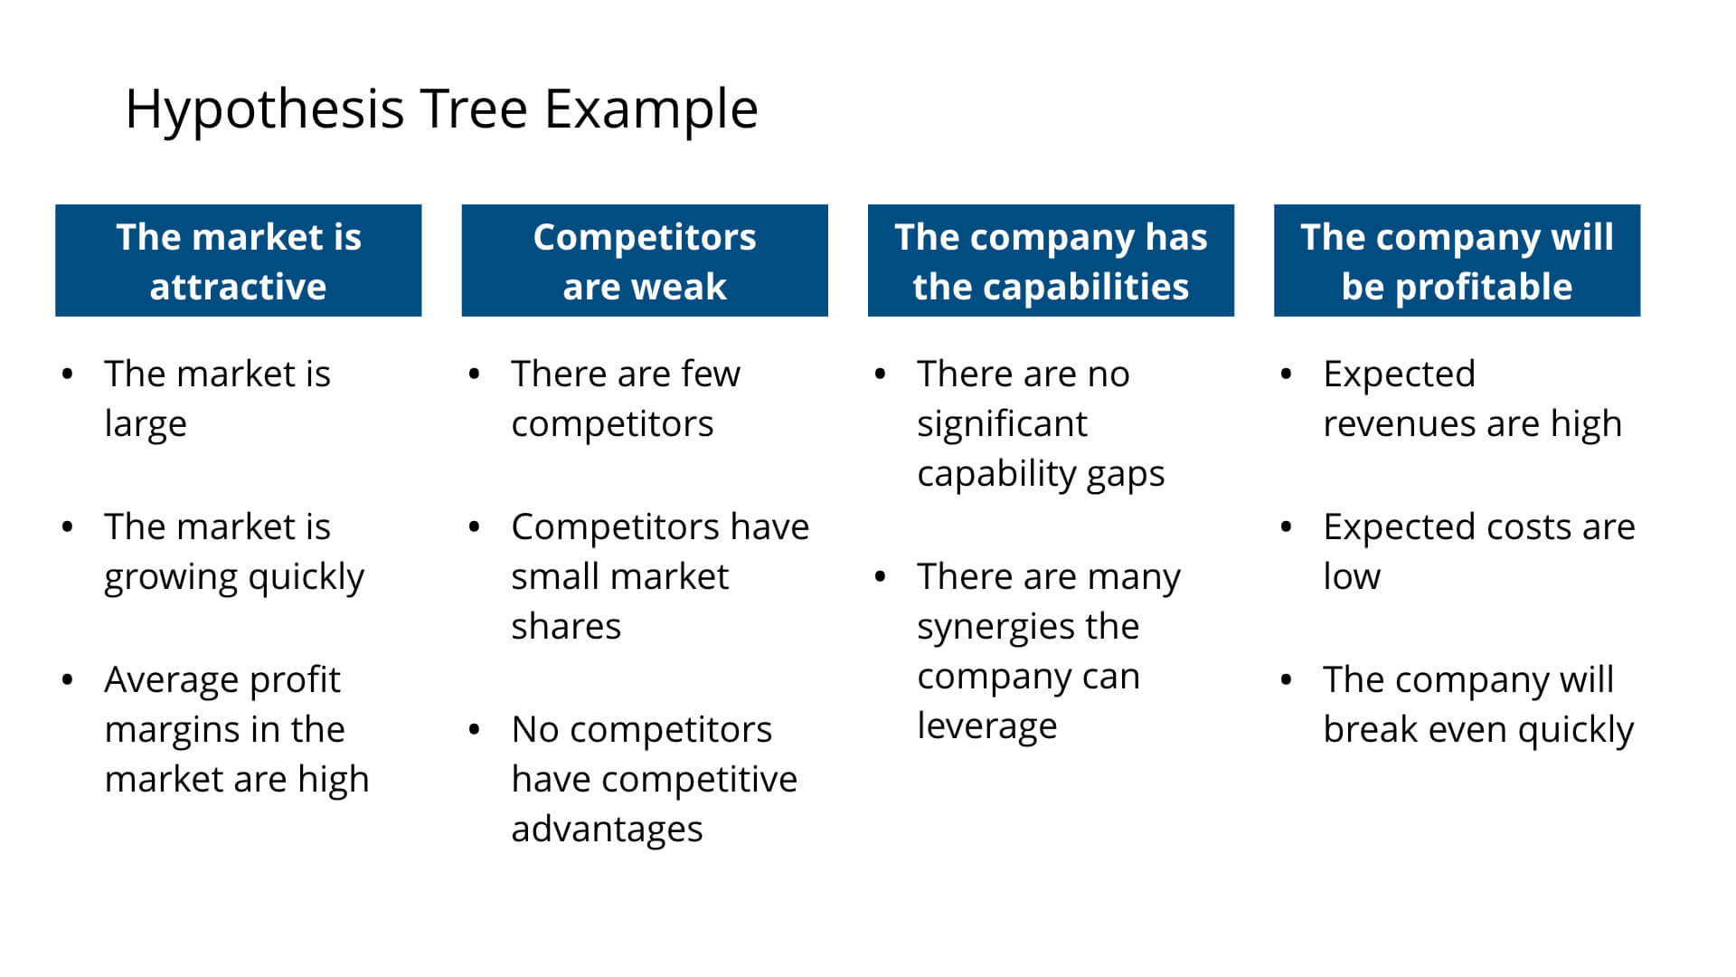

As you can see, hypothesis trees are issue trees, but reframed to focus on supporting a hypothesis rather than on solving an issue.

**Issue Tree Examples**

Below are four issue tree examples for five common types of business situations and case interviews.

If you want to learn strategies on how to create unique and tailored issue trees for any case interview, read this [**ultimate guide to case interview frameworks**](https://hackingthecaseinterview.thinkific.com/pages/case-interview-frameworks).

**Profitability Case Issue Tree Example**

Profitability cases ask you to identify what is causing a company’s decline in profits and what can be done to address this problem.

A potential issue tree template for this case could explore four major issues:

* What is causing the decline in profitability?

* Is the decline due to changes among customers?

* Is the decline due to changes among competitors?

* Is the decline due to market trends?

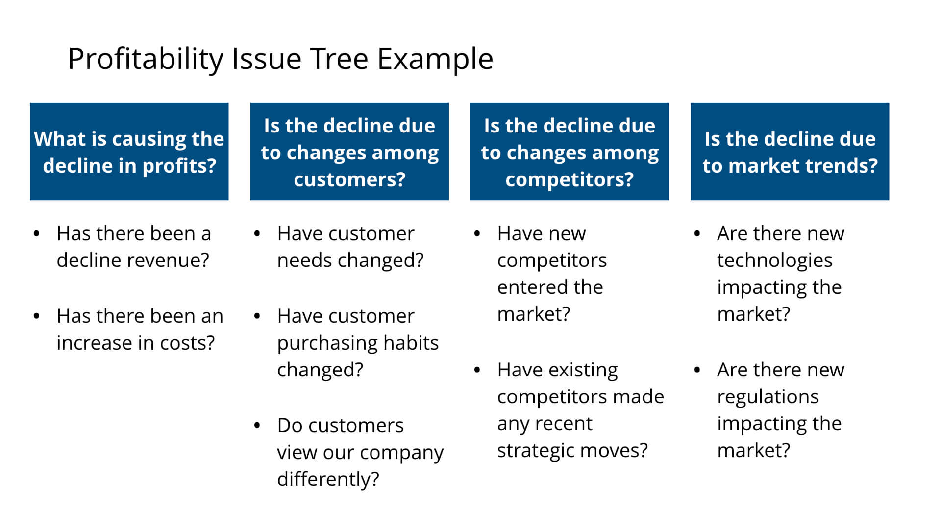

**Market Entry Case Issue Tree Example**

Market entry cases ask you to determine whether a company should enter a new market.

A potential issue tree template for this case could explore four major issues:

* Is the market attractive?

* Are competitors strong?

* Does the company have the capabilities to enter?

* Will the company be profitable from entering the market?

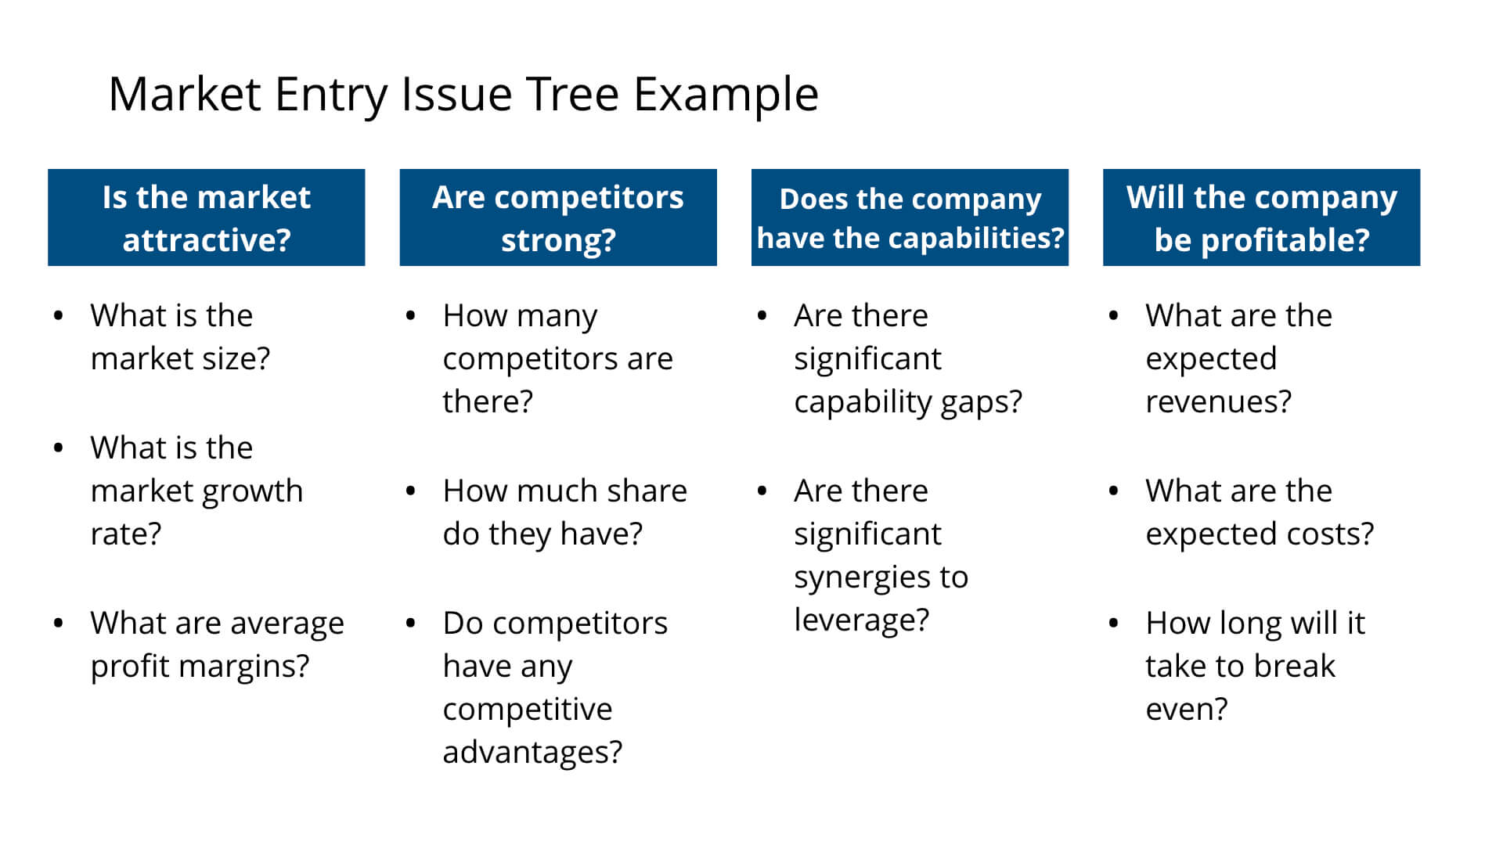

**Merger and Acquisition Case Issue Tree Example**

Merger and acquisition cases ask you to determine whether a company or private equity firm should acquire a particular company.

A potential issue tree template for this case could explore four major issues:

* Is the market that the target is in attractive?

* Is the acquisition target an attractive company?

* Are there any acquisition synergies?

* Will the acquisition lead to high returns?

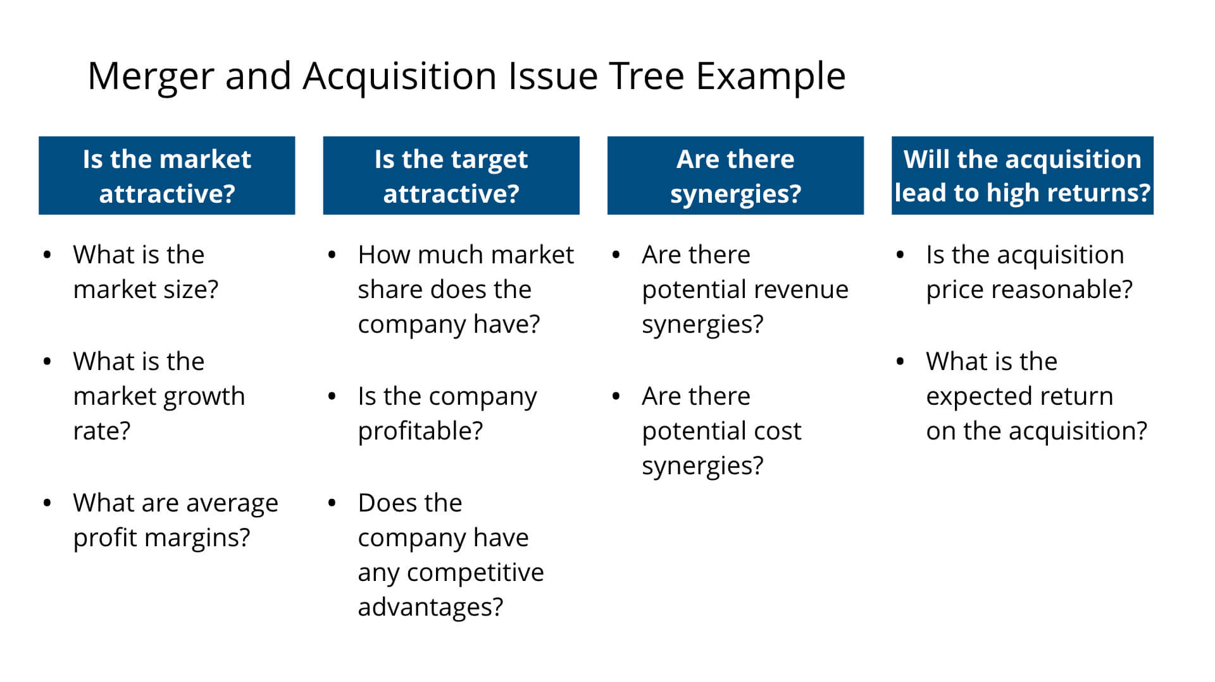

**New Product Case Issue Tree Example**

New product cases ask you to determine whether a company should launch a new product or service.

A potential issue tree template for this case could explore four major issues:

* Is the market attractive?

* Will customers like the product?

* Does the company have the capabilities to successfully launch the product?

* Will the company be profitable from launching the product?

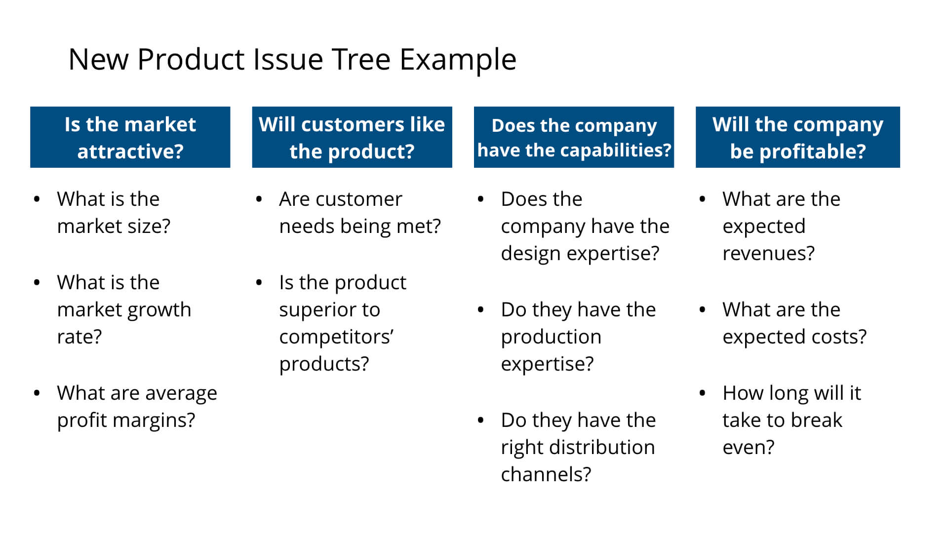

**Pricing Case Issue Tree Example**

Pricing cases ask you to determine how to price a particular product or service?

A potential issue tree template for this case could explore three major issues:

* How should we price based on the costs?

* How should we price based on competitors’ products?

* How should we price based on customer value?

